ASSIGNMENT AIAC 9.5
2303A51015(SRIKARAN) BATCH-01
Problem 1: String Utilities Function
Consider the following Python function:
def reverse_string(text):
return text[::-1]
Task:
1. Write documentation in:
o (a) Docstring
o (b) Inline comments
o (c) Google-style documentation
2. Compare the three documentation styles.
3. Recommend the most suitable style for a utility-based string
Library
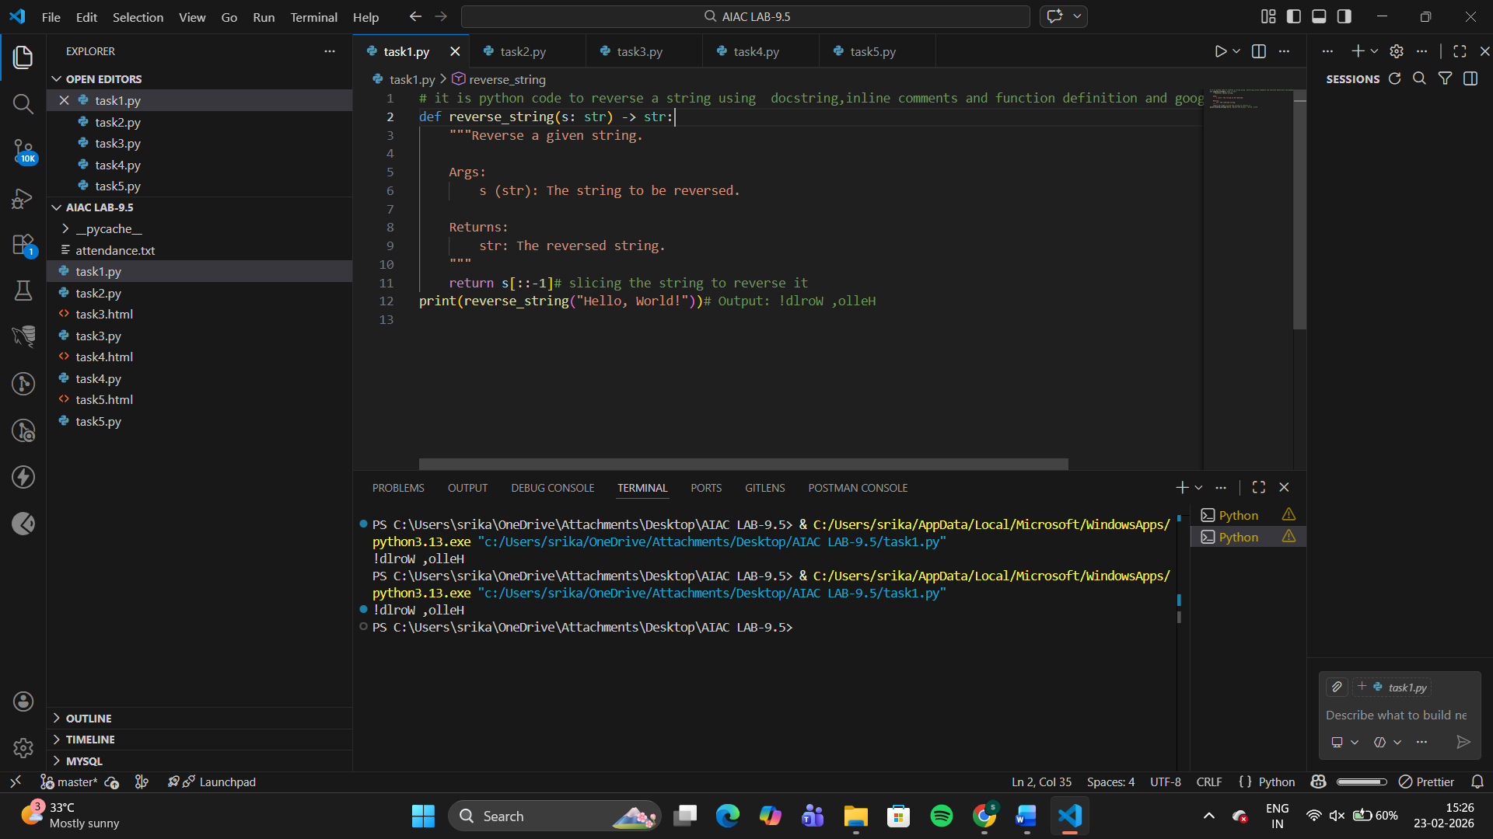
Comparison of documentation style
Style | Purpose | Pros | Cons
Docstring (basic) | Standard internal documentation | Simple, readable, built-in help() support | Not structured for large projects
Inline comments | Explain logic step-by-step | Helpful for beginners | Clutters code if overused
Google-style | Structured documentation for teams/libraries | Professional, tool-friendly, readable, supports auto-docs | Slightly longer to write
Best Style for a Utility-Based String Library
Google-style documentation
Works well for reusable utility libraries
Supported by documentation generators (Sphinx, MkDocs, etc.)
Easy for teams to understand
Problem 2: Password Strength Checker
Consider the function:
def check_strength(password):
return len(password) >= 8
Task:
1. Document the function using docstring, inline comments, and
Google style.
2. Compare documentation styles for security-related code.
3. Recommend the most appropriate style
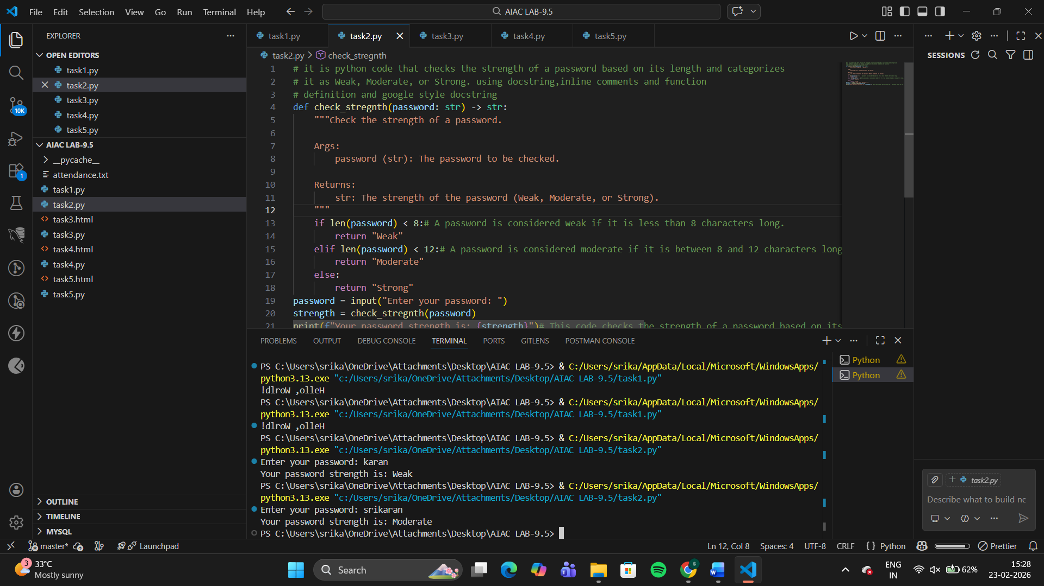
Comparison of documentation style
Style | Suitability for Security Code | Reason
Basic docstring | Medium | Explains purpose but lacks structured warnings or notes
Inline comments | Low | Good for developers but not enough for audits/reviews
Google-style | High | Supports structured notes, warnings, and future improvements
Recommended Style
Best choice: Google-style documentation
Clear enough for security audits
Allows adding Notes / Warnings / Examples
Problem 3: Math Utilities Module
Task:
1. Create a module math_utils.py with functions:
o square(n)
o cube(n)
o factorial(n)
2. Generate docstrings automatically using AI tools.
3. Export documentation as an HTML file
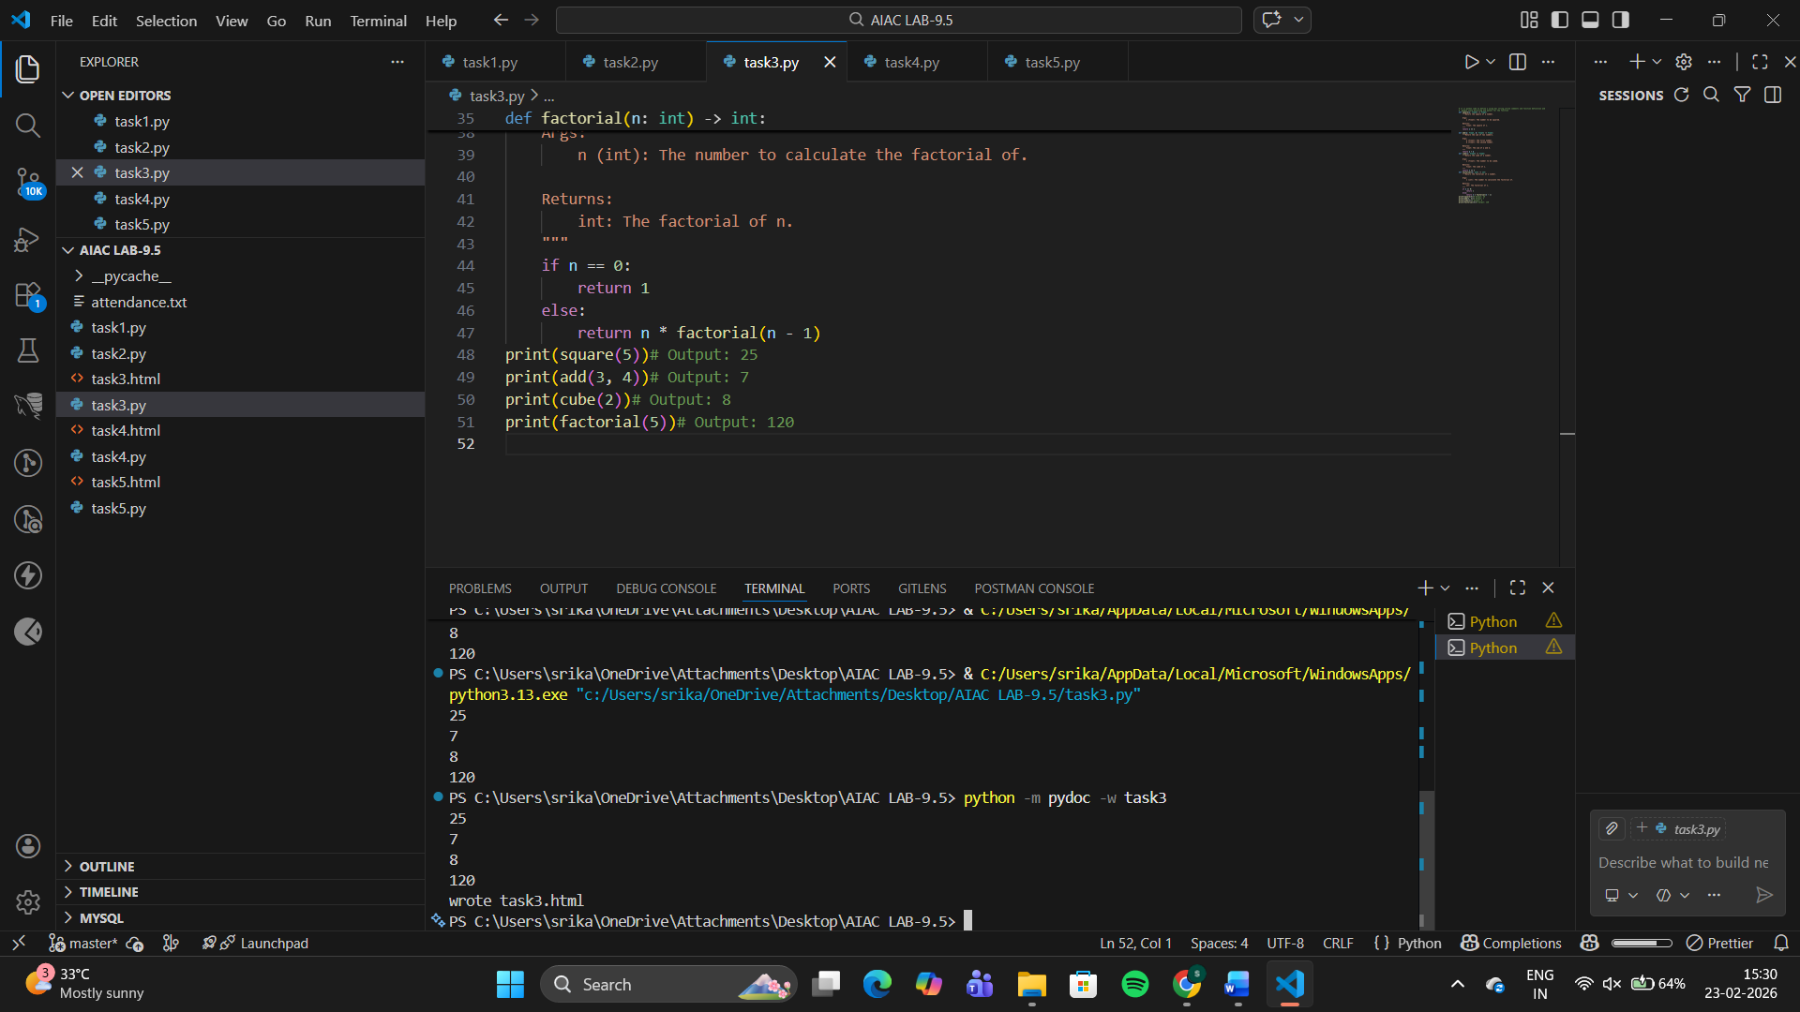

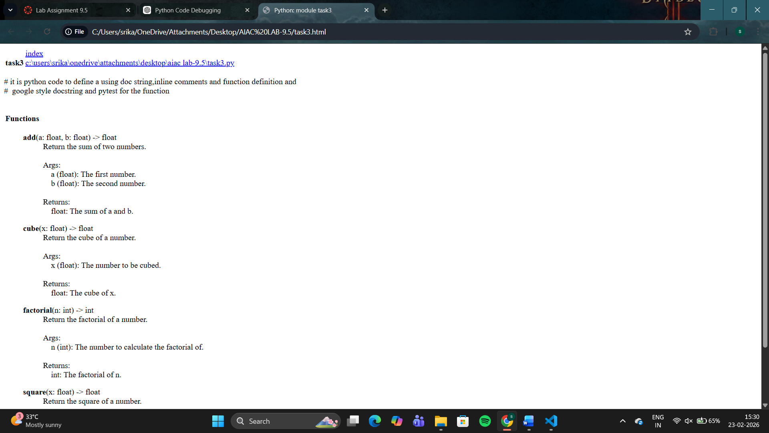
Problem 4: Attendance Management Module
Task:
1. Create a module attendance.py with functions:
o mark_present(student)
o mark_absent(student)
o get_attendance(student)
2. Add proper docstrings.
3. Generate and view documentation in terminal and browse
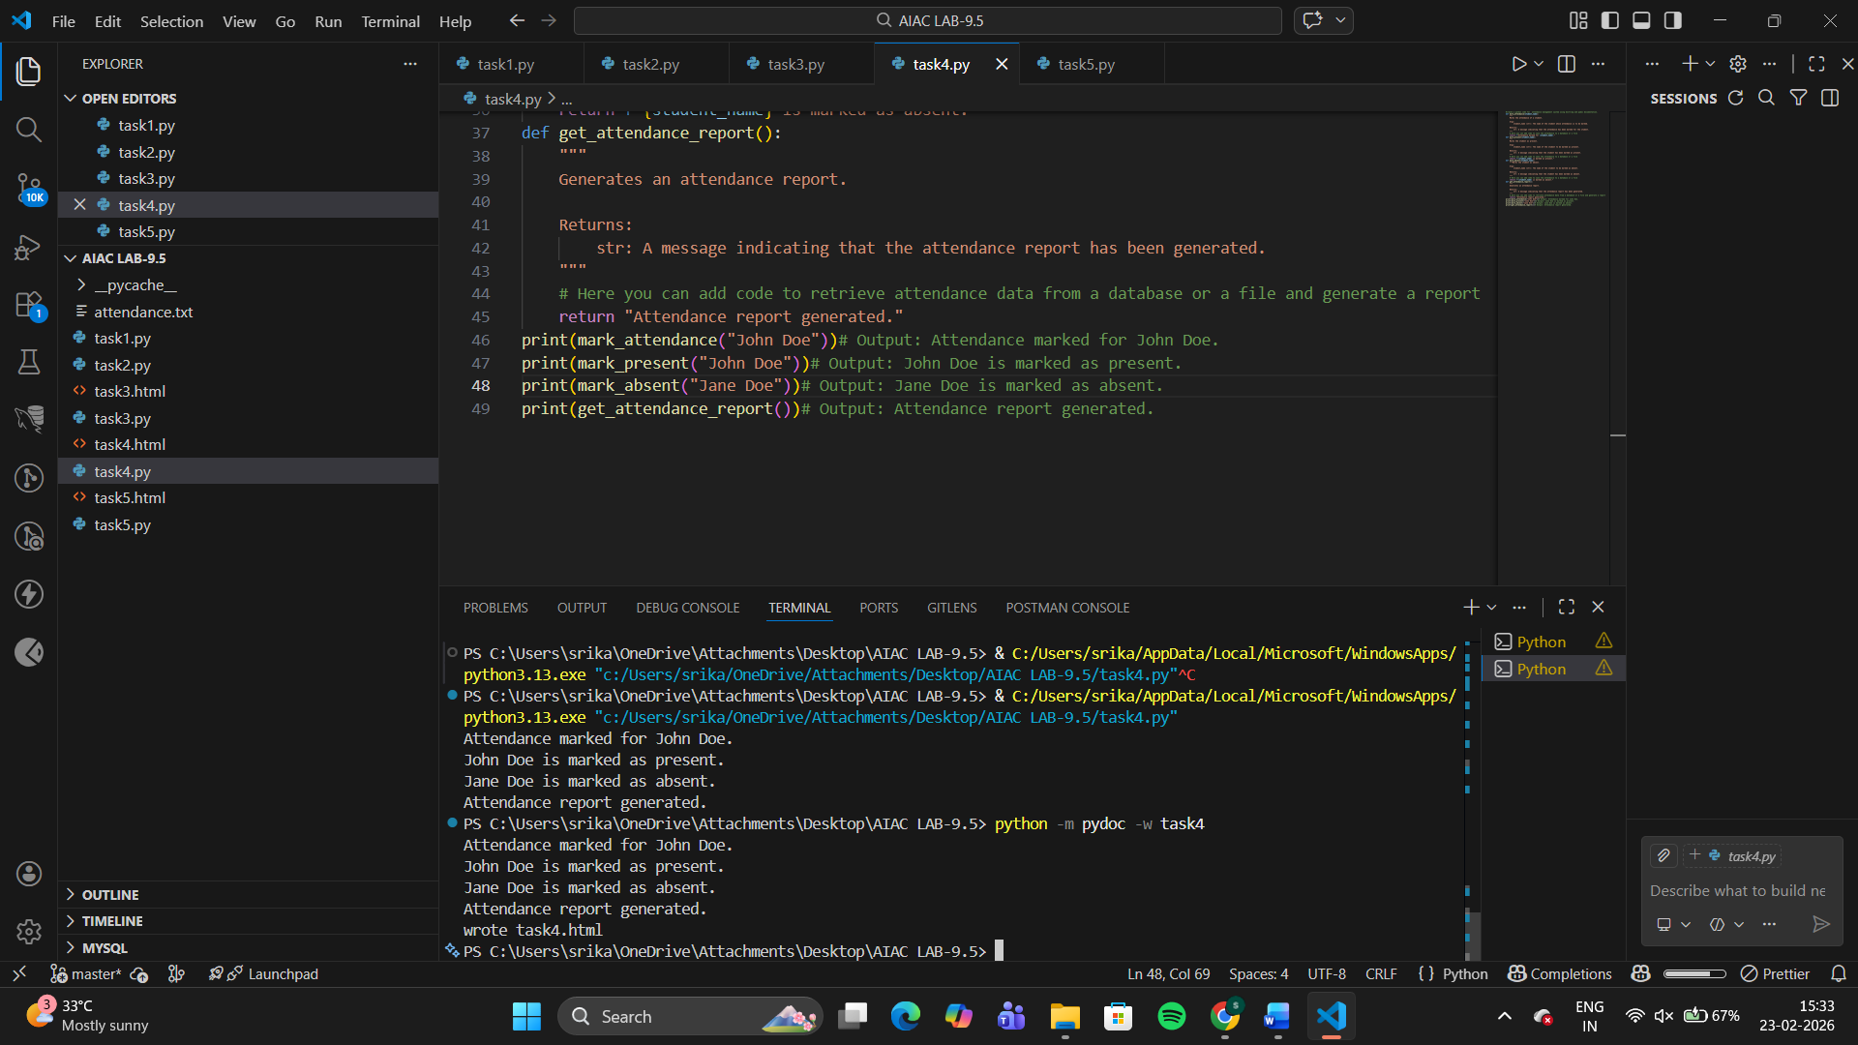
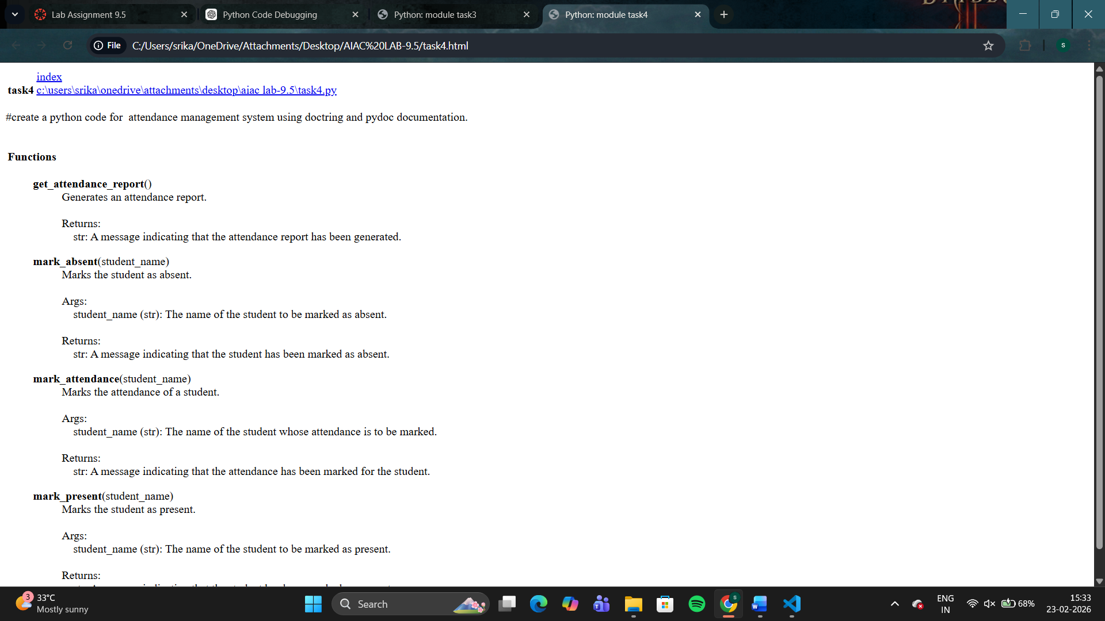
Problem 5: File Handling Function
Consider the function:
def read_file(filename):
with open(filename, 'r') as f:
return f.read()
Task:
1. Write documentation using all three formats.
2. Identify which style best explains exception handling.
3. Justify your recommendation
